CRM Project

Functional Specification - Enhancement

PP6

CRM.PP6.CM-090-150-260-E.CM_ENH_280- Contract Mgt MO Summary

(Object id: CM_ENH_280)

Deliverable Name | PP6 Enhancement Functional Specifications
Date | 02/01/11
Revision | V4.0
Signed off By
Signoff Date

TABLE OF CONTENTS

1. Version 3
2. Approvals 3
3. Priority Mention the Priority of the object from the FRICEW list in ILM. Processing Mode (check all that apply) 3
Low Medium High 3
4. Enhancement Requirements Description 4
5. Impacted Systems 4
6. Approach to be followed < List the type of enhancement whether it is a user exit, BADI or Custom transaction> 4
7. Roles and Volumes 4
8. Security & Control Requirements 5
8.1 Security Requirements 5
8.2 Control/Audit Requirements – N/A 5
9. Dependencies 5
9.1 Development Dependencies 5
CM-090-150-160-E.CM_ENH_290 - Contract Mgt End Contract & Meter Data 6
9.2 Run/Execution Dependencies 6
9.3 Archiving Dependencies - NA 6
10. Execution Steps 6
10.1 Process Description 6
10.2 Process Flow 6
10.3 As-Is Systems Referred To 7
10.4 Processing Options 7
11. Enhancement Description 8
• Contracts Ending at Premise 8
• Address – Final for Ending Contracts 8
• Customer Info Notes 8
• Notifications 8
• Submit 8
11.1 Detailed Description of the Enhancement 8
11.2 UI Design and Screen Flow < Mention the WEBUI Design in the sense the mock up screens and the navigation flow between the screens etc> 10
11.3 Access Method or Path for Enhancement 11
11.4 Required Custom Tables (if known) - NA 11
11.5 Error Handling Rules 12
12. Enhancement Reconciliation & Testing Requirements 12
12. 1 Data Validation 12
12. 2 Testing Reconciliation - NA 12
12.3 Performance Issues - NA 12
13. Additional Information - NA 12
14. Open Items- NA 12
15. Functional Unit Test cases <Here they should list the possible test scenarios in the table below> 12

Version
Ensure that any approved change requests that affect scope are documented in the revision history and include CR #.
Version | Change Description | Author | Date Released | Sections Impacted
Enter in the version number | Brief description of the change | Who made the change | Date change was made | Mention the sections impacted with this change
1.0 | Initial creation | Cecilia Shepherd | 11/01/10
2.0 | Control and Audit requirements verbiage | Cecilia Shepherd | 01/11/11 | 8.2
3.0 | Added Roles and volume, corrected the Table of Contents, corrected section numbers | Cecilia Shepherd | 01/12/11 | 7, 12, 13, 14, 15
4.0 | Change the landing page for cancel process, changed the screen shot on the cancel process, confirmed development items, added testing in FUT | Cecilia Shepherd | 02/01/11 | 11.1, 15
5.0 | As pre Change Request CHG04246 – Update logic to disable the Submit button if Errors have occurred in the End Contract process. Item 5, page 10 | Judy Jarone | 8/31/2011 | 11.5

Approvals
The individuals listed below will be required to review and approve this document.
Reviewers Title | Reviewer Role | Name
Project Title of Reviewer | Reviewer's Role (Responsible, Approve, Consult, Inform) | Reviewer's Name
CRM Functional Team Lead | Approve | Robert Smeltekop
Technical Team Lead | Approve | V. Krishna Karunakaram

Priority
Mention the Priority of the object from the FRICEW list in ILM.
Processing Mode (check all that apply)

Low Medium High

Enhancement Requirements Description

<This section should contain a detailed description of the business requirements for this enhancement in business terms. Please insert any description of the business flow which would aid in understanding this process.>

The Summary View provides the agent with an overview of the Contract prior to submitting it. Prior to submission, all errors must be resolved thereby reducing the number of downstream errors.

Each section of the Summary View will display relevant information the agent can communicate to the business partner. The information displayed in each of the assignment block in the Summary view is data collected from the previous steps in the Contract Management End Contract process framework.

Impacted Systems

<This list should include systems that are being impacted as a result of this enhancement.>

CRM 7.0 Web IC : CRM 7.0 Web Client Interaction Center Production System
ECC 6.0 / IS-U ECC 6.0 / IS-U : Back End Production System (Enterprise Central Component)

Approach to be followed
< List the type of enhancement whether it is a user exit, BADI or Custom transaction>

The existing Contract Summary process step will be enhanced to add additional assignment blocks (Address, Notification, and Customer Info Notes)

Roles and Volumes
<Describe information regarding users and volumes. Make sure to note if the use of this development will require additional communication and/or training. Also, specify what the volume requirements will be needed by the Go-Live date.

Complete the table below with the correct project-specific information for this functional specification. Instructions are in the middle row, and a sample entry is in the bottom row.>
Role | Estimated Volume Requirement | Comments
List name of role; should come from the list of security roles | Enter the estimated volume requirements that will be needed by the Go-Live date | Enter other comments including if this development will require additional communication and/or training
CSR 2, 3, 4, VCC MGMT | 1,000,000 / Year
BCOS | +- 75 / Day
Billing | +- 75
Consumer Affairs | +- 75
Revenue Recovery | +- 75

Security & Control Requirements

Security Requirements
<Describe any security requirements that need to be put in place as a result of this development object. This could include security access to affected transactions or new transactions that may result from this development. If the enhancement has to be archive enabled, list additional security to be added to the roles.> NA

Control/Audit Requirements – N/A

Describe any control requirements that need to be put in place as a result of this development object>.
•If applicable, please answer the question and also provide detail to the question .
•The questions listed below are not all inclusive to the control requirement that may be required. If there are any other controls requirements please document them as well.
- Indicate if this enhancement is being developed to address a control requirement?
▪Financial/SOX Impact - Does the enhancement have any impact to financial reporting? If yes, is the amount significant (i.e. greater than $35 million annually)? Please provide an estimate.
▪Regulatory Impact - Does the enhancement have any impact to regulatory compliance (i.e. FERC, NERC, etc)? If yes, please provide a reference to the rule and describe the impact.
▪Operational Impact - Is the enhancement relied upon for a mission critical process or providing services to customers? If yes, please identify the mission critical process and describe how this enhancement is used in the context of this process.

Dependencies

Development Dependencies
<List the configuration, development, and other work that must be considered during the creation of this enhancement.>

CM-090-150-160-E.CM_ENH_290 - Contract Mgt End Contract & Meter Data
CM-090-150-220-E.CM_ENH_300 - Contract Mgt End Address Maintenance
CM-090-150-040-E.CM_ENH_390 - Contract Mgt End Contract Notification

Run/Execution Dependencies
<Once in production, this development object may need to be executed before or after another system event. List other system events that this development object should follow or precede. If the enhancement is to be archived enabled, does it need to have adequate archived sessions, info structures, etc established in order to test/execute.>

The Summary process step is dependent on the following process steps in the End Contract process framework:
- Contract and Meter data
- Notification
- Address Maintenance

The output from all these steps will be summarized in this view.

Archiving Dependencies - NA
<List how the changes would impact archiving, if the enhancement impacts existing archived objects (i.e. table structures). Also list what needs to be regression tested from an archiving perspective.>

Execution Steps

Process Description
<Explain the process for when this development object will be used. If this is tied back to a certain task within a process you may insert the Task Profile document here as well.

Enter any of the following information available:
- Transaction Code
- User Exits
- Performance Consideration
- Z Tables created
- Code reuse.

This view is the fourth step of the Contract Management – End Contract process framework. The Contract Management - End Contract is a sub menu from the CRM IC Web Navigation bar. It can also be accessed from the Contract Management Search viewset.

Process Flow
<Create a diagram that visually depicts the process.>

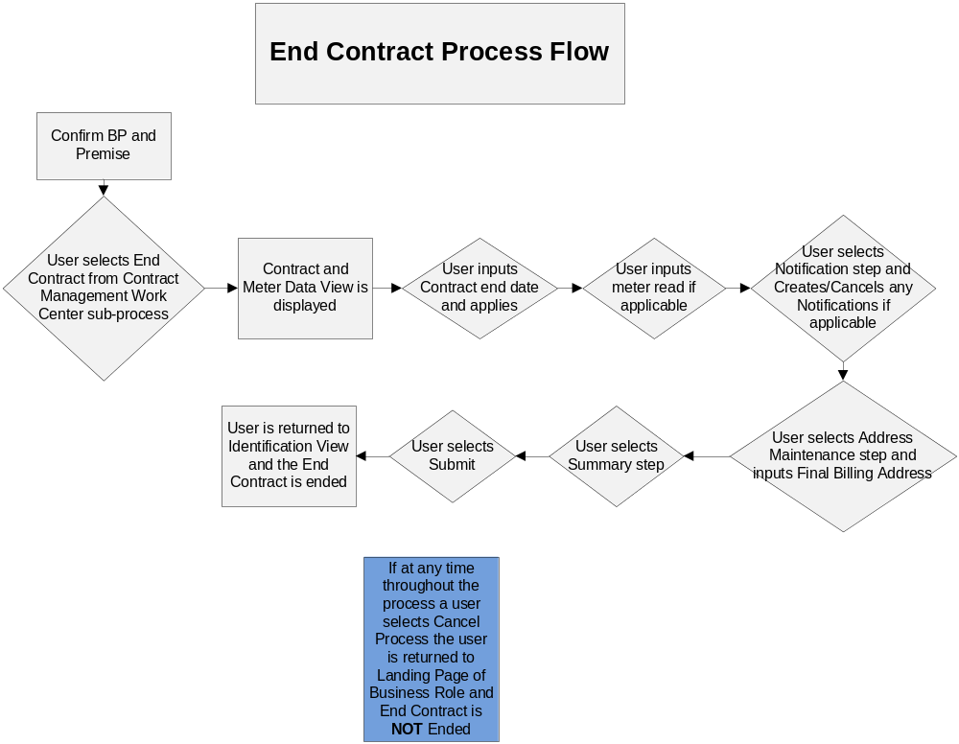

As-Is Systems Referred To
<List the systems that the task pertaining to this development object is performed in. If this is a new task (i.e. not being performed today), list it ‘Not applicable’.>

Execute CICO in ECC, Select Create Move-in (ZMOVE-IN) front office process.

Processing Options
<Indicate the Processing Mode, Frequency, and Lifetime of Development by selecting and placing an ‘X’ in the box next to the correct options below. Right click on the gray box, select properties, and specify “Checked”.>
Processing Mode (Select one of the following)
Batch Online – via Transaction Code Online – via Menu Path
On demand

Frequency (Select one of the following)
Daily
Weekly Quarterly
Monthly Annually
Other (If other, describe here)

Lifetime of Development (select one)
Permanent
Temporary, e.g. until rollouts are complete, specify details here

Enhancement Description
<Provide a brief description of the enhancement.>

The Summary View provides the agent with an overview of the End Contract prior to submitting it. Prior to submission, all errors must be resolved thereby reducing the number of downstream errors. Each section of the Summary View will display relevant information the agent can communicate to the business partner.

Each section of the Summary View will display relevant information the agent can communicate to the business partner. The information displayed in each of the assignment blocks in the Summary view is data collected from the previous steps in the Contract Management End Contract process framework.
- Contracts Ending at Premise
The standard Contracts display will provide the agent with the premise address, Division, Product, Desired End Date and Description. These fields are display only.
- Address – Final for Ending Contracts
The Address – Invoice for End Contract will display the mailing address the customer selected from the Address Maintenance step. These fields are display only.
- Customer Info Notes
The Customer Info Notes view will allow the agent edit customer information notes created during service order creation or create a new note.
- Notifications
Notifications created during the End Contract process will be displayed.
- Submit
The submit button will commit the work performed by the agent and navigate to the Fact Sheet.

Detailed Description of the Enhancement
<Provide a written description of the functionality that needs to be developed. Identify/describe the SAP application transaction that uses or is used to invoke the enhancement. Describe tables, transactions, reports, forms, screens and other objects that need to be created or modified. Insert a Visio flow diagram of the process to be executed by the enhancement, and add any other information required to develop the enhancement.>

- The first assignment block will be the Contracts End at Premise. The standard Contracts display (no development necessary) will provide the agent with the premise address, division, assigned product, description, and desired start date. The data will only be in display mode.

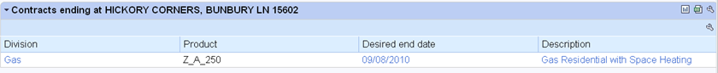

- The second assignment block will be the Address – Final Invoice for ending Contracts. This is the default mailing address from the Address Maintenance step. These fields are display only. The standard Address assignment block (no development necessary) for End Contract will be used.

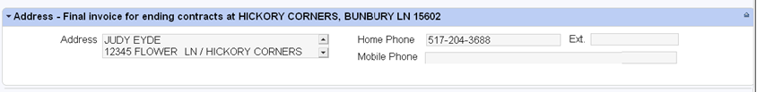

- The third assignment block will be the Customer Info Notes. This will contain the long text note that was created in the Notification step. This will allow the agent to edit customer information notes created during service order creation and/or create a new note. An enhancement is necessary to save the notes in this assignment block in the Interaction Record notes with text type equal to System Notes.

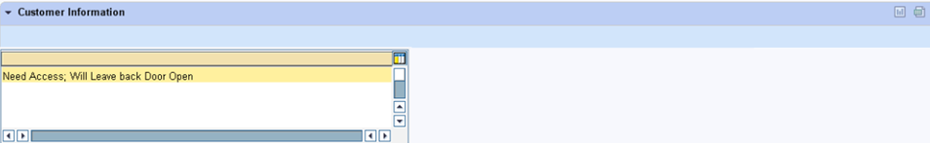

- The fourth assignment block will be the Notifications. These are all the Service Notifications created in the previous Notification step. The data will only be in display mode. An enhancement is necessary to display the data in this assignment block. The data will come from the Service Notification that was created in ECC for this account.
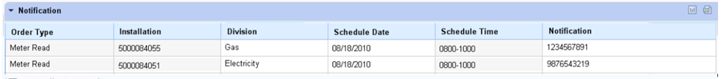

- The submit button will be disabled if a system error of type (E)rror exist in any of the process steps within the process framework. The user must resolve the errors before submitting the Contract.

The Submit button will commit the work performed by the agent. WS93000084, Move-out workflow, is triggered when the move-out document is created, which should automatically be created when the end contract is replicated from CRM to ECC.

- Cancel Process button:

Write a note in the Interaction Record that the End Contract has been cancelled.

If there were no notifications created in the Notification step, display the following pop-up message:

Are you sure you want to cancel the “End of Contract” process?

OK CANCEL

Else
Display the following pop-up message:

Are you sure you want to cancel the “End of Contract” process?
Please cancel notifications that have been created.

OK CANCEL

If the user clicks OK, then the system should navigate to the Factsheet assigned to the business role..

11.2 UI Design and Screen Flow
< Mention the WEBUI Design in the sense the mock up screens and the navigation flow between the screens etc>

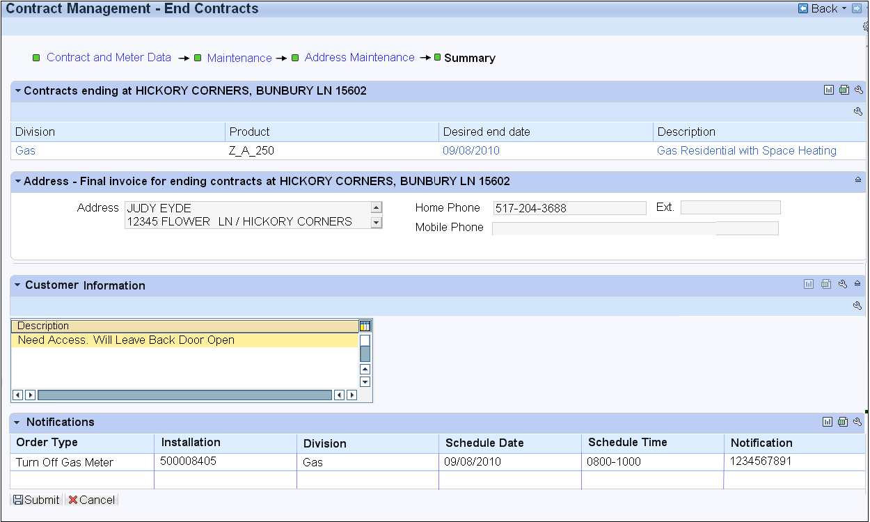

11.3 Access Method or Path for Enhancement
<Select the correct execution path below by placing an ‘X’ in the checkbox next to it and completing the description that follows. Check all that apply and add any other execution methods if required by the Client. Right click on the gray box, select properties, and specify “Checked”.>
Execution: Custom Transaction Code:
Menu Path:
Standard Transaction Code:
Other: This view will be accessed from Summary process step of the Contract Management End Contract Process framework.

11.4 Required Custom Tables (if known) - NA
<Provide any information about custom tables required for this enhancement.>
Table Name: Enter Table Name
Table Description: Enter Table Description
M/O | Field Description | Type (text or numeric) | Maximum Field Length | Value Restrictions? | Validations?
Mention M if the field is mandatory and O if the field is optional | Enter the field description | Enter the type | Enter the max. field length | Enter any value restrictions | Mention if any validations are required or else mention NA

11.5 Error Handling Rules
<Explain what the error handling rules would be if there are any for this development. For example, if an enhancement is scheduled to be printed and it does not, what should a user do to get this corrected?>

12. Enhancement Reconciliation & Testing Requirements

12. 1 Data Validation
- How will data using the enhancement be validated (e.g. compare reports, control totals etc.)?

The data displayed in the following blocks must have the same value as the data that is displayed in the previous steps:
  - Contract End at Premise - Contract detail from the Contract/Meter Data step
  - Address – Default Address from the Address Maintenance step
  - Customer Information - Long text information from the Notification step
  - Notification – List of Service Notifications created from the Notification step

- Is regression testing required from an SAP Data Archiving perspective? NA

12. 2 Testing Reconciliation - NA
- Who will test the enhancement?

12.3 Performance Issues - NA
- Any potential issues on performance – for archived enabled enhancements?

13. Additional Information - NA
<Enter any additional information that could be helpful in developing this enhancement.>

14. Open Items- NA
<This includes Risks and Issues logged in Clarity and Action Items.>
Item # | Detailed Description | Proposed Solution
Insert number | Describe the item | Describe the proposed resolution

15. Functional Unit Test cases <Here they should list the possible test scenarios in the table below>
Test Condition Description | Input Data | Expected Results | Actual Results/Comments

Test Scenarios:

Since the Summary step is a collection of all the data from the different steps in the End Contract process framework, the data cannot be confirmed without testing all the steps in the End Contract process framework.

Verify that Contract and corresponding details including Desired End Date in the Contract Ending at Premise assignment block are the same as the data in the Contract and Meter Data of the End Contract Process framework.

Verify that the Address assignment block has the same address selected in the Address Maintenance set of the End Contract Process framework.

Verify that the Customer Info Notes includes the same Notes that were created in the Notification step of the End Contract process framework. If the agent enters additional notes in this assignment block, verify that the IR notes contains the Notes from the Notification step and the additional notes entered by the agent.

Verify that the Notifications assignment block should have all the Service Notifications created in the Notification step of the End Contract Process framework should be the same.

If the user clicks on the Cancel Process button, it should display a pop-up to confirm the cancellation and If the user clicks on the OK button, navigate to the Factsheet assigned to the business role and that an Interaction record note is created to indicate that the End Contract was cancelled.

